Bishop Richard is looking forward to the Confirmation. It would help him in preparing for the visit if you could kindly complete this form and return it to Bishop's Lodge, Woolton Park, Liverpool. L25 6DT at least 3 weeks prior to the date of the Confirmation, together with a draft order of service.

Date of Service: | Wednesday 21st March 2018 |  |  |  |  |  |  | Time: |  | 7.30pm
(please note that weeknight services begin at 7.30pm)
If Sunday pm please consider earlier times (e.g. 3pm or 4pm)
Location:  (Church – number of nearest house in street/road) |  |  | St Andrew’s Church: corner of Poplars Avenue and Howson Road
Post code for sat nav: |  | WA2 9UE |  |  |  | MAP ON FINAL PAGE
Name of principal contact: |  | Rev Michael Raynor |  |  |  |  | Tel no: |  | 01925 631903
 |  |  |  |  |  |  | Mobile: |  | 07964 562470
 |  |  |  |  |  |  | Email: |  | mjraynor@care4free.net
Name and mobile number of contact person on the day:  (in case of delay/hold up – or a lost bishop!) |  |  |  |  | As for principal contact
Where do you want bishop to park? In the church car park. A space will be reserved.
(please ensure a space is reserved) The entrance is from Howson Road
Number of candidates: |  | 8 children and 1 adult (at 17.2.18). 2 possible adults still considering confirmation
Other parishes involved: |  | None
Who is organising the service? Rev Michael Raynor |  |  |  |  |  |  |  |  |  | Tel. No. 01925 631903
Who has prepared the candidates? Michael Raynor

What course has been used and how long has it lasted? 9 weeks (juniors); 5 weeks adults
Who will be bishop’s chaplain? To be advised at a later date.
Will this include a baptism?  (please circle) |  |  |  |  |  | YES
Will this include reception into the Church of England?  (please circle) |  |  |  |  |  |  |  |  |  | NO
Will this include Holy Communion?  (please circle) |  |  |  |  |  | YES
Do you wish the bishop to anoint the candidates?  (please circle) |  |  |  |  |  | YES
How do you want bishop vested? Chasuble and Mitre (Red)
(please circle)
Is there anything he should be aware of in respect of any of your candidates? (please circle) |  |  |  |  |  |  |  |  |  | NO
If yes, please give details: |  |  |  | May change: one possible adult has mobility difficulties and may be easier if the bishop were willing to confirm in the pew. Will advise if he chooses to be confirmed.
PLEASE ENCLOSE A DRAFT COPY OF THE ORDER OF SERVICE
PTO

Instruction from Bishop Richard regarding Confirmation Candidates

Bishop Richard wishes the candidates to be presented to him by the Minister (or his/her deputy) standing at his side and saying clearly and audibly as each candidate approaches: “Bishop I present N…………”

Bishop Richard has requested that candidates do not present themselves either verbally or with a piece of paper/card on which their name is written.

At least two weeks before the Service please send to Bishop’s Lodge a list of names and addresses of the Candidates in order that Bishop Richard can write a personal note to each candidate.

Map to St Andrew’s Church, Orford WA2 9UE

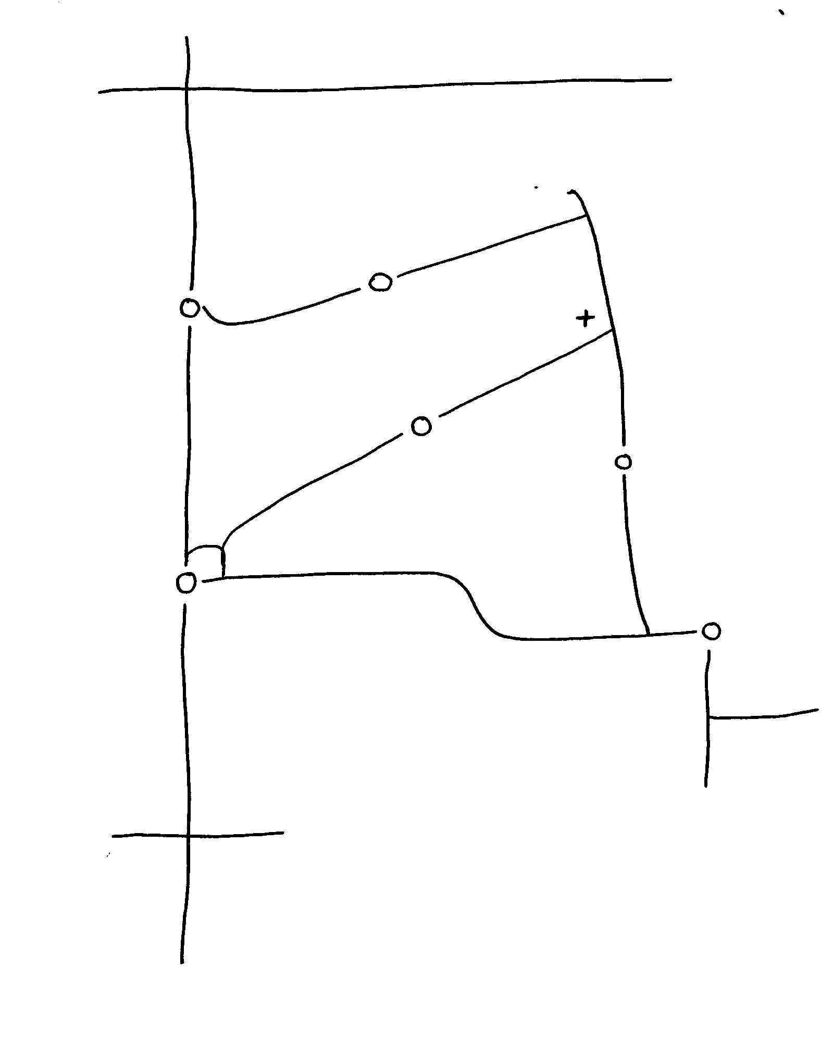

B & Q Junction 9 M62 to Manchester ➔

A49 to
Warrington
↓ Cleveland Rd
Poplars Avenue
Aldi

Sandy  St Andrew’s
Lane West School Church and Hall

Howson
CAR PARK
ENTRANCE
Road

Northway

Long Lane

Birchwood Way

McDonald’s Fire Station
Drive - In

A49 to Town
Centre ⬇

